Report: Producer Consumer Algorithm

1. Explain the problem and identify evaluation metrics for experiments
   1. Two processes, the producer and the consumer, are connected to each other. The producer will read and put characters of a string onto a buffer for the consumer to read. The problem arises when the buffer is full and the producer cannot place more characters onto it or when the buffer is empty and the consumer cannot grab anything. When these issues occur, resources end up being wasted and it may take longer. We can solve this by using conditional variables and using mutex. Conditional variables will tell when a thread can start. If the buffer is full, then the producer can wait to push more variables into it. If the buffer is empty, the consumer can wait until there is something in the buffer to print it.
2. Explain your choice of threading libraries
   1. I chose pthreads because it was taught in class and I have previous exposure from another class that I took.
3. Explain the design of the experiment and develop programs for evaluation
   1. I started off with the main function and adding in basic stuff like file opening and creating the basic threads. Then I went on to create the producer and consumer classes. For the producer, I want to check if the queue is full and if it is then I would wait until it is empty. Then, I try to push a character onto the queue and then send a signal to prime the consumer for action. The consumer would then check if the queue is empty and then try to grab the first element in the queue and print it out. The consumer then sends a signal to the producer telling it that its ok to do work. The process will continue until there is no more string to be read and printed.
4. Detail your collected experimental results
   1. Portion of MLK Speech (1st image)
   2. “the world is quite round and not flat at all.” (2nd image)

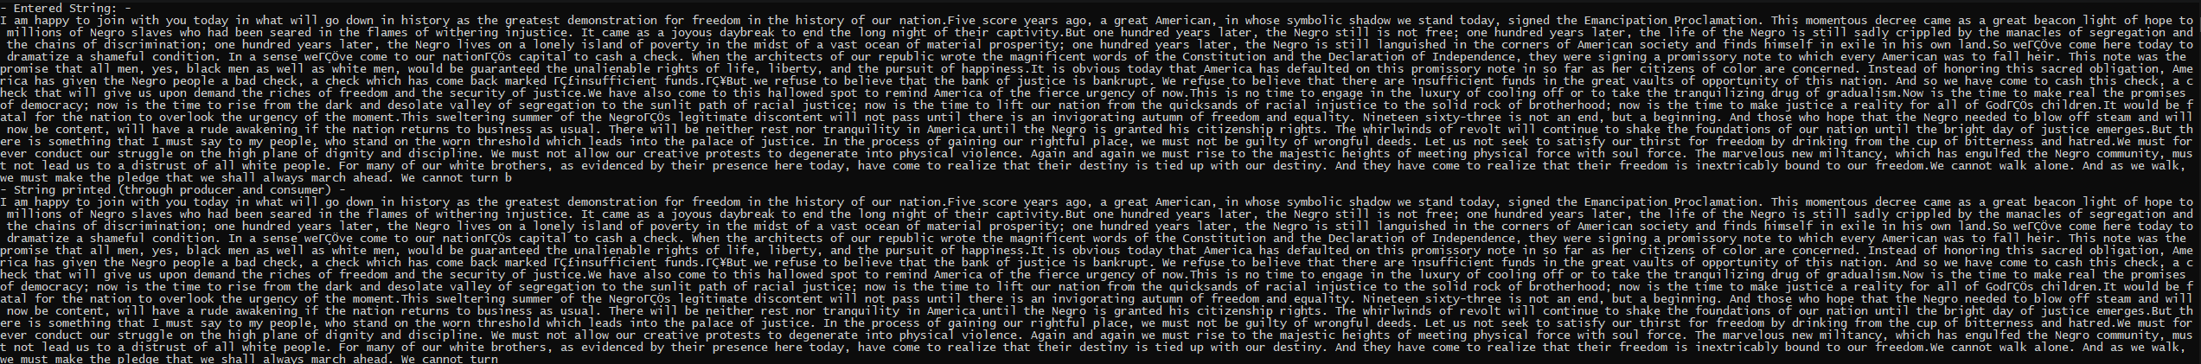

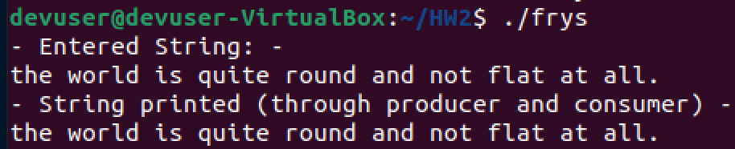

1. Analyze, graph, and interpret experimental results and draw conclusions
   1. Compared to manually just scanning each character and printing it out without threads, the process of threading and conditional variables seems to be a lot faster. Speeds were reduced by huge margins and it is definitely worth investing into big programs that may require lots of resources.